Leaflet Graph

## Find Winner of each State

euElections %>%

Kreisebene:

Level = 2

„NAME_2“

group_by(Gebietsname) %>%

filter(Prozent == max(Prozent)) -> euWinners

## Load Spatial-Polygons-DF for Germany



germany <- getData("GADM", country="Germany", level=1)



## Merge Geo-Data and Winner-Data

germany@data %>%

left_join(euWinners, by=c("NAME_1"="Gebietsname")) -> germany@data

## Define Color Palatte

pal = colorFactor(palette = c("black", "grey", "red", "green", "blue"),

levels = c("CDU", "CSU", "SPD", "GRÜNE", "AfD"))

## Create Simple Map

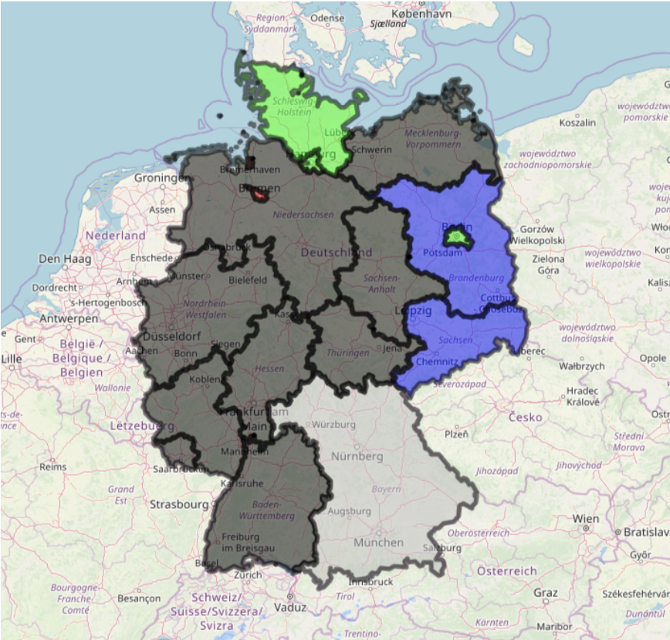leaflet() %>%

addTiles() %>%

addPolygons(data=germany,

fillColor = ~pal(Gruppenname),

fillOpacity = 0.5,

color = "black")

## Create more detailed Map

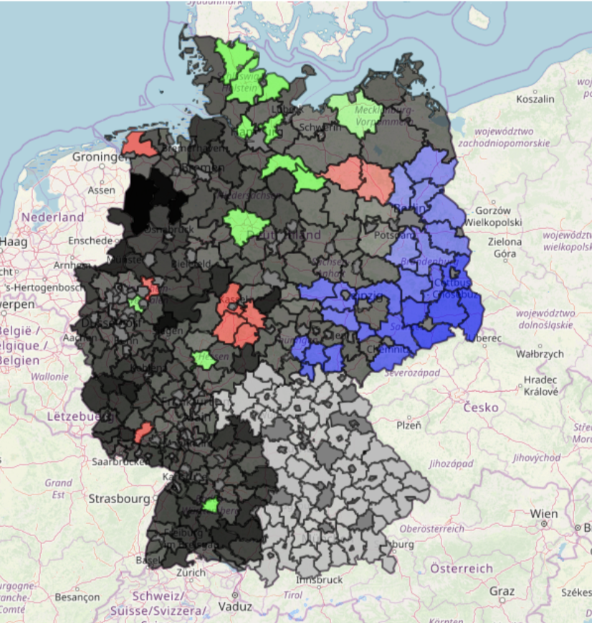 leaflet() %>%

addTiles() %>%

addPolygons(data=germany,

fillColor = ~pal(Gruppenname),

fillOpacity = ~Prozent/50,

color = "black",

weight = 2)